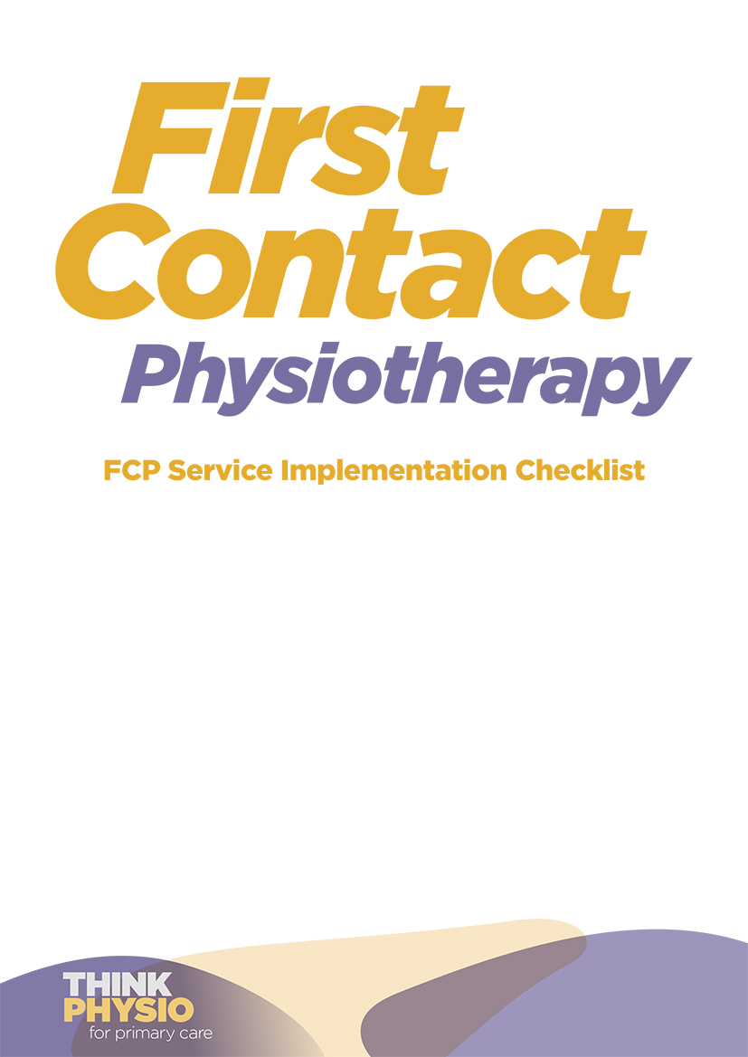
This is an example checklist to be adapted as required.
 | Date✓ | Notes
FCP service and workforce planning | Date✓ | Notes
Define clinical model of service provision including skill mix required for service delivery supported by sustainable job planning.
Develop recruitment and redeployment strategy.
Develop job specification and job descriptions for Band 7 and/or Band 8a.
Check the provision and scope of indemnity cover.
Consider equality impact assessment.
Review and consider application of Health Education England Roadmap (if in England), AHP Framework (if in Wales), Scottish education quality framework (if in Scotland) and Advanced AHP framework (if in NI)
Stakeholder engagement | Date | Notes
Identify an executive sponsor(s) and clinical champion(s) who will advocate for FCP service development and encourage wider engagement.
Seek input from a cross-system implementation team. (Stakeholders may include MSK service GPs, ICATS or similar triage services, practice managers and teams, secondary care consultants, CCG, STP and Federation leads, Primary Care Network clinical directors, patient participation groups/representatives, Primary care training hubs)
Develop mechanisms for communicating with stakeholders (that include the wider primary and secondary care team) so to collect and respond to their views, concerns and expectations.
Introduce the FCP service to the practice team (ensuring that they understand the role, the service’s purpose and aims, and how it differs from other physiotherapy services).
Practical considerations | Date | Notes
Agree clinic room availability and frequency of clinics with Practice Manager. Ensure facilities accessible for those with physical difficulties and facilities have appropriate infection control measures (hand washing) and sufficient space for face to face appointments.
Provide appropriate equipment (e.g. printer, adjustable height plinth, computer, telephone)
Agree diary template (appointment length, number of patient slots, amount of admin time, breaks, telephone slots, CPD / mentoring time in accordance with job plan).
Provide full access to patient records within the Practice’s EPR system (e.g. EMIS, System One, Vision) with training, as required.
Arrange access to systems for appointment booking, referral, investigation request and review, interpreting services and (if applicable) prescribing medications.
Agree clinical documentation standards.
Ensure IT support is available to FCP(s).
Ensure mechanisms for providing prescriptions and for issuing the Allied Health Professions Advisory Fitness for Work Reports.
Provide access to interpreting services
Ensure the FCP has access to (virtual and paper) patient exercise and information materials and directories / information on local services and activities for social prescribing.
Source injection equipment and ensure appropriate storage (if applicable).
Protocols, procedures and safety | Date | Notes
Organise radiology requesting rights and determine responsibility for interpreting, following up and acting on results in routine and urgent cases. (Ensure standard operating procedures are agreed.)
Organise requesting rights for blood testing and microbiology analysis and determine responsibility for interpreting, following up and acting on results in routine and urgent cases. (Ensure standard operating procedures are agreed.)
Agree procedure for requesting and reviewing investigations.
Ensure specific Patient Group Directions (PGDs) for non-prescribers (if applicable).
Agree the supply and storage of injection equipment and medicines.
Ensure that there is a Non-Medical Prescribing (NMP) policy in place.
Ensure access to pathways for all services (including for social prescribing and reablement services).
Ensure access to referral pathways for urgent or red flag secondary care referrals.
Consider practice policies with reference to providing chaperones as requested or required.
Agree clinical/medical emergency plan: adverse drug reactions, anaphalaxysis, red flags, cardiac arrest, first aid and medical kit etc.
Agree procedure for patient correspondence
Agree non-face to face service delivery policy (video consultation, telephone appointments)
Governance for FCP staff | Date | Notes
Ensure clear operational structures and line management are in place.
Identify nominated individuals in the practice (and provider, if applicable) for overseeing clinical, administrative, indemnity and governance matters.
Create and agree a training and development plan in line with Health Education England roadmap (if in England).
Agree protected time for CPD.
Create an induction programme for newly employed / contracted FCPs.
Agree clinical support and supervision to ensure safety and development towards / maintenance of competence (e.g. mentorship, peer review, watched assessments and case reviews.)
Ensure FCPs are invited to (primary care and pathway-based) MDT meetings.
Ensure mechanisms are agreed for reporting and managing risks, incidents and complaints.
Identify methods of reporting sickness and staff cover.
Identify methods for requesting annual leave and staff cover.
Ensure CQC adherence and liaise with practice manager regarding evidence required
Ensure appropriate level of PLI depending on service model
Ensure policies and procedures agreed: sickness, annual leave, whistle blower/freedom to speak up, complaints and complements, finance (including expenses if appropriate).
Ensure mandatory training is accessible for staff
Liaise with Patient Participation Group around implementation of service
Care navigation and service promotion | Date | Notes
Update GP (online and telephone) booking systems to enable direct FCP appointments.
Provide training and resources to primary care team on the FCP service and care navigation.
Promote the service to the public using all available marketing channels (e.g. posters, signage, practice website and social media channels, waiting room television screens, the practice’s patient newsletter, at patient / local events and via local media).
Service evaluation and data collection | Date | Notes
Priorities and strategic direction set and communicated
Agreed reporting mechanisms to stakeholders
Agree data collection mechanisms including analysis and dissemination.
Establish and discuss mechanisms to assess impact of the FCP service.
Upload appropriate data collection and reporting templates.
Allow protected time for service evaluation.
Arrange procedures for the collection of patient experience and outcome data (using a Patient Satisfaction Questionnaire and/or alternative methods).

If in England, please review Health Education England roadmap for templates.
Consider other measures of quality and effectiveness (e.g. GP and staff feedback).
Allow time for regular patient satisfaction surveys
Agree schedule for audit (image requesting, record keeping, performance and safety KPI audit, prescribing)

