**Report from the CSP Welsh Board meeting - 31st of March 2022**

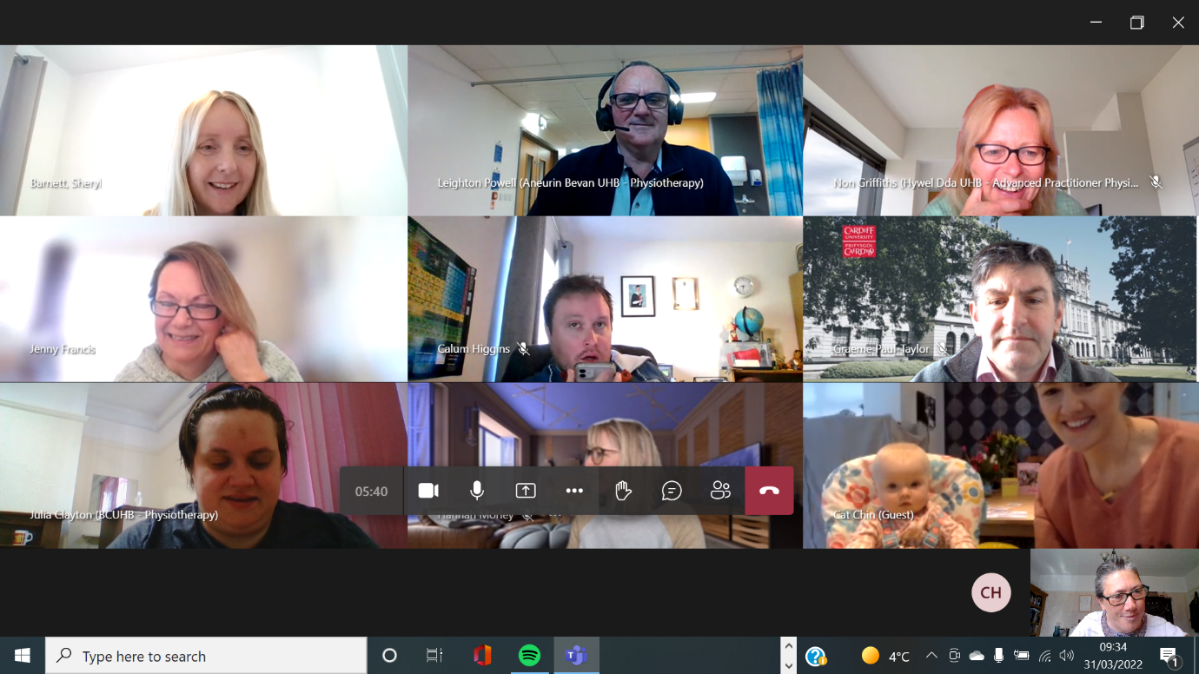

Spot the #tinycspwelshboardmember

CSP Welsh Board held their March meeting virtually via Teams and acting chair Sheryl Barnett welcomed guests to the meeting including Claire Fordham, CSP Professional Advisor, Jill Morgan, Senior Lecturer Cardiff University and Liz Hargest, Work-based Education Development Manager in Health Education and Improvement Wales (HEIW).

**CSP Welsh Board AGM**

The Board held their AGM and Leighton Powell was re-elected as Treasurer and Julia Clayton was re-elected as Secretary. It was lovely to see Cat (Welsh Board Chair on maternity leave) and her little one on the virtual call. Rowy Jones is standing down as Communications Officer but will stay on the Board as a South West Wales rep. The Board recorded huge thanks to Rowy for all her contribution over the years as Comms Officer – she taught us all how to do twitter! @CSPWales now have 1,908 followers up from 1,750 last year.

**Calum Higgins, CSP Public Affairs and Policy Manager (@calumcsp)** updated Welsh Board on all the activities at the Welsh Spring Political Party Conferences. These have provided a useful opportunity for the CSP to influence on a range of key issues, particularly growing the workforce and the importance of rehabilitation.

The ‘streamlining’ system for new graduates was discussed and continues to be a difficult area of work. Calum indicated that Welsh Government may look at the Bursary and its ‘tie-in’ to staying and working in Wales again – he hopes it is something the new Minister for Health and Social Care, Eluned Morgan MS may wish to do. HEIW has done a review of the ‘streamlining’ process which is going to the HEIW Board. The CSP Welsh Board noted that the whole ‘streamlining’ process has worked better for the nursing profession than for AHPs. For any further detail – [higginsc@csp.org.uk](mailto:higginsc@csp.org.uk)

**Hannah Morley, CSP Professional Advisor in Wales (@HannahMorleyNHS)** had great pleasure in giving the Board a guided tour of the new ‘Stronger My Way’ resource from the CSP which was launched on the day of Welsh Board. <https://www.csp.org.uk/campaigns-influencing/campaigns/stronger-my-way> Members are encouraged to access the hub and explore all the resources which will be really useful both for clinicians and patients. Clinicians looking for evidence base and training resources/opportunities will find a wide range of tools and information. Patients will find videoclips, information in a range of formats. It’s excellent!

Hannah also updated the Board on PhysioUK which is not running in 2022. There is a project team looking at it and considering potential ways forward. Hannah is keen to hear from any members who have ideas and contribution to make. CSP is open to suggestions. Contact her – [morleyh@csp.org.uk](mailto:morleyh@csp.org.uk)

**Adam Morgan, CSP SNO (@AdamM_CSP)** updated the Board on a range of ERUS issues including pay talks, continuing difficulties with the loss of physiotherapy work spaces and business committee issues including, Long Covid pay, mileage allowance and the staff welfare project. Board members were particularly concerned about fuel price increases impacting on members and the need to increase mileage rates. This is very much on the agenda for the Wales Partnership Forum.

The Reps Race Equality Group have been meeting regularly and are set to present to the Wales Physiotherapy Leaders Advisory Group (WPhLAG) in April.

CSP has 2 motions to Wales TUC, one on the loss of rehabilitation space and one on implementing adjustment passports in all public bodies.

For any further information on this contact [morgana@csp.org.uk](mailto:morgana@csp.org.uk)

**Non Griffiths** (**@non104Griffiths)** fed back on the **Welsh Allied Health Professions Committee (WAHPC)** and highlighted that the meeting in January was cancelled. The next one is due in May 2022. The big drivers for WAHPC this year will be:

1) Progress the work of the AHP Framework Programme. Welsh Government now have a Programme Team in place along with a Governance Structure. Physiotherapist Gethin Harries has become the AHP lead for Rehabilitation and is keen to link with services across Wales

2) Progress the work on Primary & Community Community Care especially on the accelerated Primary Care Cluster development and community infrastructure.

Non informed the Board that she had attended a virtual update/training session on the primary and community care development and there is a lot of work going on to shift the work of AHPs into primary care. This area will be the focus of a workshop at the June CSP Welsh Board (in person – yippee!) meeting in mid-Wales. For any further information contact [non.griffiths2@wales.nhs.uk](mailto:non.griffiths2@wales.nhs.uk)

**Newly Qualified Physiotherapist rep report –** Charlotte Hamilton-White reported back to the Board on the findings of her recent survey of newly qualified physiotherapists. The report was well received. Adam Morgan said that it would prove very useful to use the findings to inform the sessions CSP TeamWales provide to the graduating cohort. Hilary Mott said it would be very useful information to share with WPhLAG. There was a discussion around the anxieties for newly qualified physiotherapists being ‘on call’ and feeling confident with respiratory competencies. Board members shared a wide range of resources and ideas.

**Update on Support Worker Development** – The Board received a paper and an oral update from Claire Fordham, CSP Professional Advisor and lead for the support worker membership on developments for support workers across the UK to provide a background for discussions about progress in Wales. Claire talked about a range of ‘insight work’ that has been undertaken in the various parts of the UK and she said that an FOI was going to all Health Boards in Wales to ascertain take up of the Diploma in Physiotherapy Support – how many have been registered and how many have completed the full diploma since its implementation in 2018.

Liz Hargest, Work-based Education Development Manager at HEIW provided an over-view of how the level 3 Diploma in Physiotherapy Support and level 4 Diploma for Therapy Assistant Practitioners will be integral to the developing Therapies Apprentice Pathway level 4. Will Oliver, Assistant DoTHS, Hywel Dda UHB will chair a group that is going to oversee this development for HEIW. Liz highlighted that there is HEIW funding to support HCSWs in gaining their qualifications – it has mostly been meeting the costs of the course but it has also included some infrastructure funding – she is pleased to see the AHPs applying for this funding. There will be a new post in Liz’s team in HEIW to support assessors and increase the numbers of assessors in the workplace. This has been a barrier to support workers being able to enrol. She also highlighted that there should be a flow of additional ‘apprenticeship’ funding that would come to organisations where staff were enrolled in apprenticeship training.

As Claire mentioned in her overview, the service needs to be innovative and create the types of posts that the therapies apprentices can grow into. The meeting provided an excellent opportunity for CSP officers and HEIW to link and for the Board to have a clearer view of where Wales is in comparison with the rest of the UK. For more on this issue contact [fordhamc@csp.org.uk](mailto:fordhamc@csp.org.uk)

**Bringing the Environment and Sustainability into Physiotherapy Education –** Jill Morgan, Senior Lecturer Cardiff University

The Board heard an excellent presentation from Jill <https://www.csp.org.uk/documents/bringing-environment-sustainability-physiotherapy-education> – All members are advised to have a look at her PowerPoint which includes crucial information and a range of organisations and links that are well worth looking at and getting involved with. Jill is happy to hear from anyone who wants more information or would like to join the Cardiff University on-line community. [morganj63@cardiff.ac.uk](mailto:morganj63@cardiff.ac.uk)

Environmental Physiotherapy Agenda 2023 have launched 2 new posters – the links are in the PowerPoint – have a look! Also, checkout PhysioDeclares - @physio_declares on twitter.

**Equality, Diversity and Belonging – update from the education sector**

Julie Wilkins had provided a paper from Glyndŵr University and Graeme Paul Taylor provided a verbal update from Cardiff University. They provided valuable feedback on what the Universities are trying to do to ‘widen access’ including using ‘contextual admissions’. Graeme talked about the Equality, Diversity and Inclusion approach being taken in Cardiff University and work to target schools with a range of different projects and initiatives. He also talked about how they are working with the programmes (pre and post reg) to build the future profession – with a focus on ‘valuing a diverse workforce’. Students have been encouraged to be part of the interview process and attend roadshows and careers fairs – as Graeme says “Students are our best ambassadors!” Any thoughts/ideas you might have for supporting the education sector is attracting the physiotherapy workforce that reflects our communities – Julie and Graeme would love to hear from you! Send ideas through to [Wales@csp.org.uk](mailto:Wales@csp.org.uk)

**Welsh Board Objectives 2022 -** These were signed off and are available on the Wales page of the CSP website – <https://www.csp.org.uk/documents/csp-welsh-board-objectives-2022>

**AOB**

1) Look out for details on an event for CSP members in Wales on Strengthening and ‘Stronger My Way’ – likely July 2022

2) Calling all Private Practitioners in Wales! – Maria Lewis and Pip Ford are going to hold an evening zoom event – looking at dates in late June 2022

3) Approaching retirement? – The CSP Retirement Association (CSPRA) has just launched a revised CSP Retirement Pack - <https://www.csp.org.uk/publications/retirement-pack>

Pip Ford MBE MCSP, Acting Communications Officer for CSP Welsh Board – March 2022